**Introduction to MS Excel**

**MS-EXCEL**is a part of Microsoft Office suite software. It is an electronic spreadsheet with numerous rows and columns, used for organizing data, graphically representing data(s), and performing different calculations.  It consists of 1048576 rows and 16384 columns in **Excel 2007 and later versions**, a row and column together make a cell. Each cell has an address defined by column name and row number example A1, D2, etc. This is also known as a cell reference.

**What is MS Excel**

Microsoft Excel is a software application designed for creating tables to input and organize data. It provides a user-friendly way to analyze and work with data. The image below provides a visual representation of what an Excel spreadsheet typically appears like

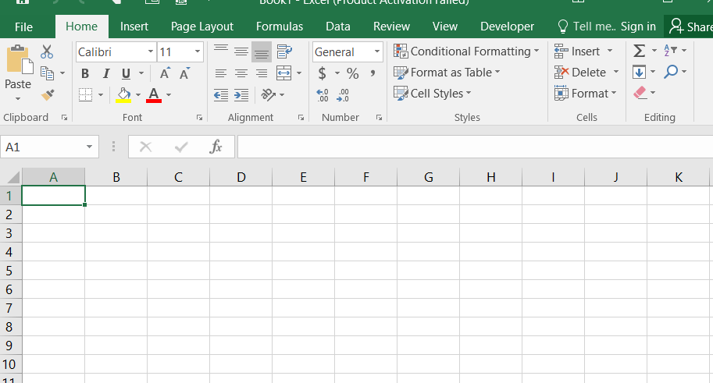

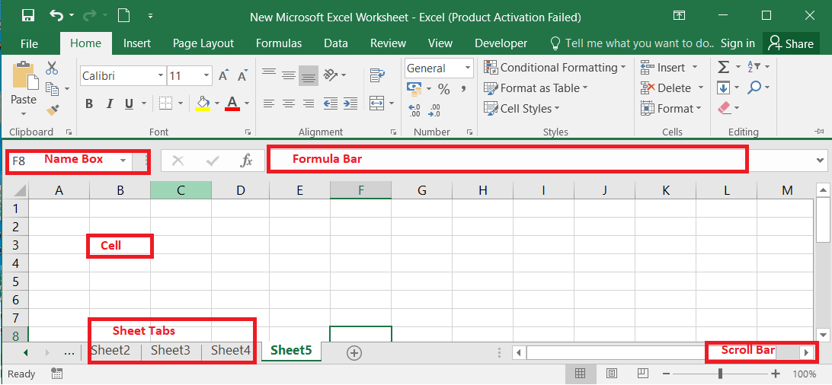

**Excel Interface**

**What is a Cell**

A spreadsheet takes the shape of a table, consisting of rows and columns. A cell is created at the intersection point where rows and columns meet, forming a rectangular box. Here’s an image illustrating what a cell looks like:

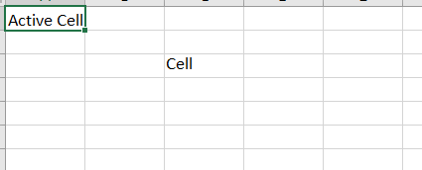

**What is Cell Address or Cell Reference**

The address or name of a cell or a range of cells is known as Cell reference. It helps the software to identify the cell from where the data/value is to be used in the formula. We can reference the cell of other worksheets and also of other programs.

* Referencing the cell of other worksheets is known as External referencing.
* Referencing the cell of other programs is known as Remote referencing.

There are three types of cell references in Excel:

1. Relative reference.
2. Absolute reference.
3. 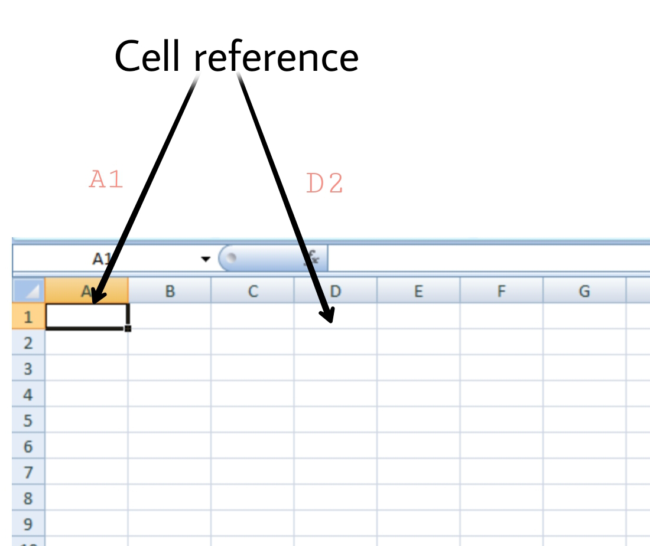Mixed reference.

**Features of MS Excel**

**Ribbon**

Th eRibbon in MS-Excel is the topmost row of tabs that provide the user with different facilities/functionalities. These tabs are:

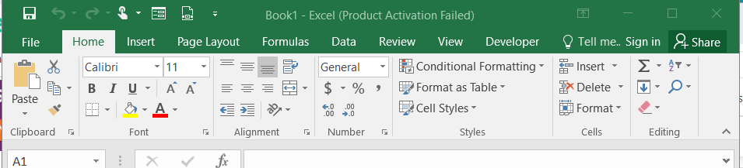

**Home Tab**

It provides the basic facilities like changing the font, size of text, editing the cells in the spreadsheet, autosum, etc.

**Insert Tab**

It provides the facilities like inserting tables, pivot tables, images, clip art, charts, links, etc.

**Page layout**

It provides all the facilities related to the spreadsheet-like margins, orientation, height, width, background etc. The worksheet appearance will be the same in the hard copy as well.

**Formulas**

It is a package of different in-built formulas/functions which can be used by user just by selecting the cell or range of cells for values.

**Data**

The Data Tab helps to perform different operations on a vast set of data like analysis through what-if analysis tools and many other data analysis tools, removing duplicate data, transpose the row and column, etc. It also helps to access data(s) from different sources as well, such as from Ms-Access, from web, etc.

**Review**

This tab provides the facility of thesaurus, checking spellings, translating the text, and helps to protect and share the worksheet and workbook.

**View**

It contains the commands to manage the view of the workbook, show/hide ruler, gridlines, etc, freezing panes, and adding macros.

**How to Create a New Spreadsheet**

In Excel 3 sheets are already opened by default, now to add a new sheet :

* In the lowermost pane in Excel, you can find a button.
* Click on that button to add a new sheet.
* We can also achieve the same by Right-clicking on the sheet number before which you want to insert the sheet.
* Click on Insert.
* Select Worksheet.
* Click OK.

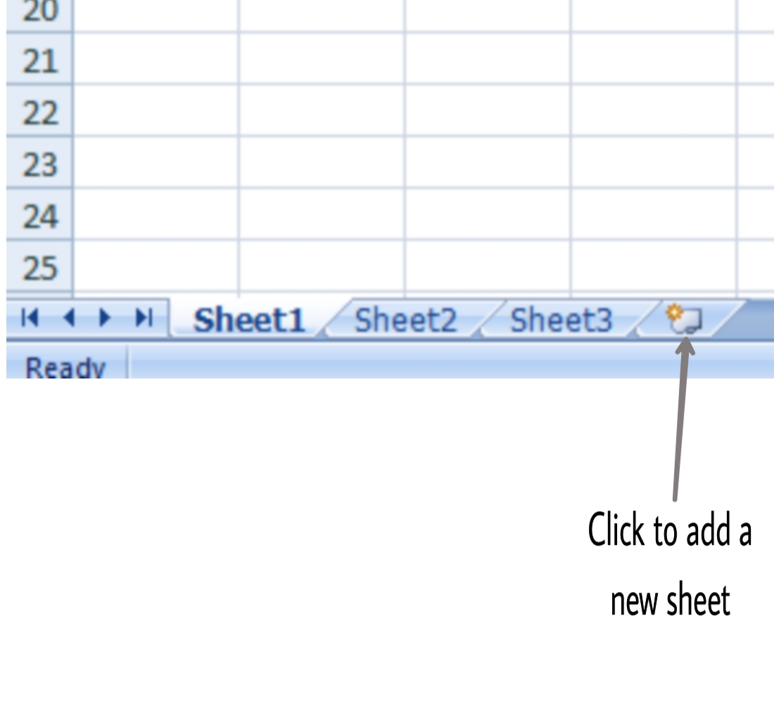

**Ms-Excel shortcuts**

1. **Ctrl+N:**To open a new workbook.
2. **Ctrl+O:**To open a saved workbook.
3. **Ctrl+S:**To save a workbook.
4. **Ctrl+C:** To copy the selected cells.
5. **Ctrl+V:** To paste the copied cells.
6. **Ctrl+X:** To cut the selected cells.
7. **Ctrl+W:**To close the workbook.
8. **Delete:** To remove all the contents from the cell.
9. **Ctrl+P:** To print the workbook.
10. **Ctrl+Z:**To undo.

**What is Ms Excel and its Features?**

*Microsoft Excel is a spreadsheet program that helps you manage and analyze data. Its key features include:*

* *Grid layout with cells for data.*
* *Formulas and functions for calculations.*
* *Charts and graphs for visualization.*
* *Data analysis tools like sorting and filtering.*
* *Collaboration and data protection options.*
* *Compatibility with various platforms.*

**What is Ms Excel Definition?**

*Microsoft Excel is a computer program that lets you create tables to store and work with information, like numbers and words. It helps with tasks like calculations, making charts, and organizing data neatly.*